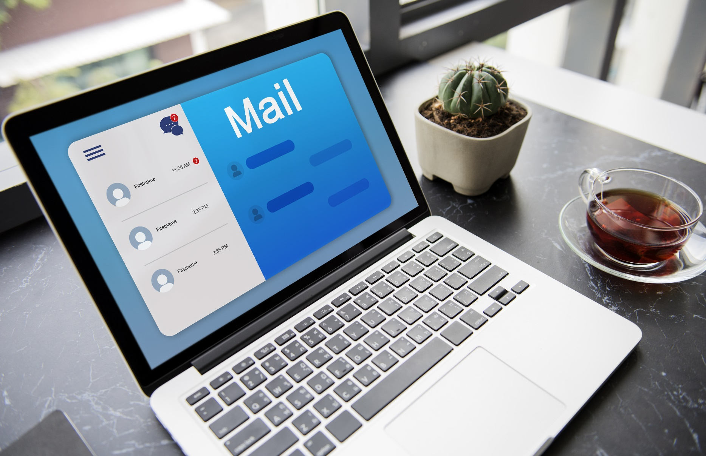

SUBJECT LINES FOR COLD- EMAILS

Subject line: [Personalized question] that can help you [achieve a goal]
- Example: Hi [name], how's your team doing with increasing your web-leads?
Subject line: How to [solve a problem] without [spending time/money/resources]
- Example: How to increase sales without spending more on advertising?
Subject line: A free [resource] to help you [achieve a goal]
- Example: Free 99 LinkedIn Connect Notes to enhance your connection.]
Subject line: [Case study] How [customer name] increased [metric] by [percentage] with [your product/service]
- Example: Case study: How Nexvan increased website traffic by 20% with our ABS Tool.
Subject line: [Personalized compliment] about [something the recipient has done]
- Example: Hi [name], I was impressed with your recent article on [topic]
Subject line: [Industry trend] that could impact your business
- Example: The rise of AI and its impact on the B2B space
Subject line: [New feature] announcement that can help you [achieve a goal]
- Example: Announcing our new feature that can help you generate more leads from your website

Subject line: [Free consultation] to see how we can help you [achieve a goal]
- Example: Sign up for a free consultation to see how we can help you increase number of closures!
Subject line: [Limited-time offer] on [your product/service]
- Example: Limited-time offer: Get 20% off our ABS Suite!
Subject line: [Personalized offer] based on your interests
- Example: Hi [name], I saw that you recently downloaded our LinkedIn In-mail Credits. Here is an extension exclusively for you.

